Label and input type password



Label and textarea (set in textarea cols, rows, maxlength, wrap, readonly.

* Wrap may be soft or hard
* readonly=”readonly” or without

Submit with Text == “I’m a button”



Radios: the group name is “piece” piece[0] .. piece[3], the same for type “checkbox”

Fieldset – legend – label – input type “radio”

Dropdown

Upload

Your own control that allows Ad12345 format



Placeholder, it shows [name@example.com](mailto:name@example.com) in gray, but when you click the text box it desappear



Datalist

Textarea, the title is a tooltip when you make a mousehover

Para enviar pagina a impression se da atributo media=”print”

**EMBED**

**id="audioID"**

**controls**

**autoplay**

**loops**

**preload="none"**

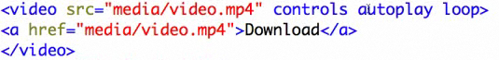

Look for a format allow in your browser, se aplica tambien al audio

